**Test Plan Validation:**

**Details and information:** Static Library file have been created and Main.cpp is coded such that the resulting matrix will be the Multiplication of input matrix 1 and input matrix 2, the resulting transpose of matrix will be the transpose taken for matrix 1.

**Pre-requisites:**

* Compile Main.cpp using g++ compiler

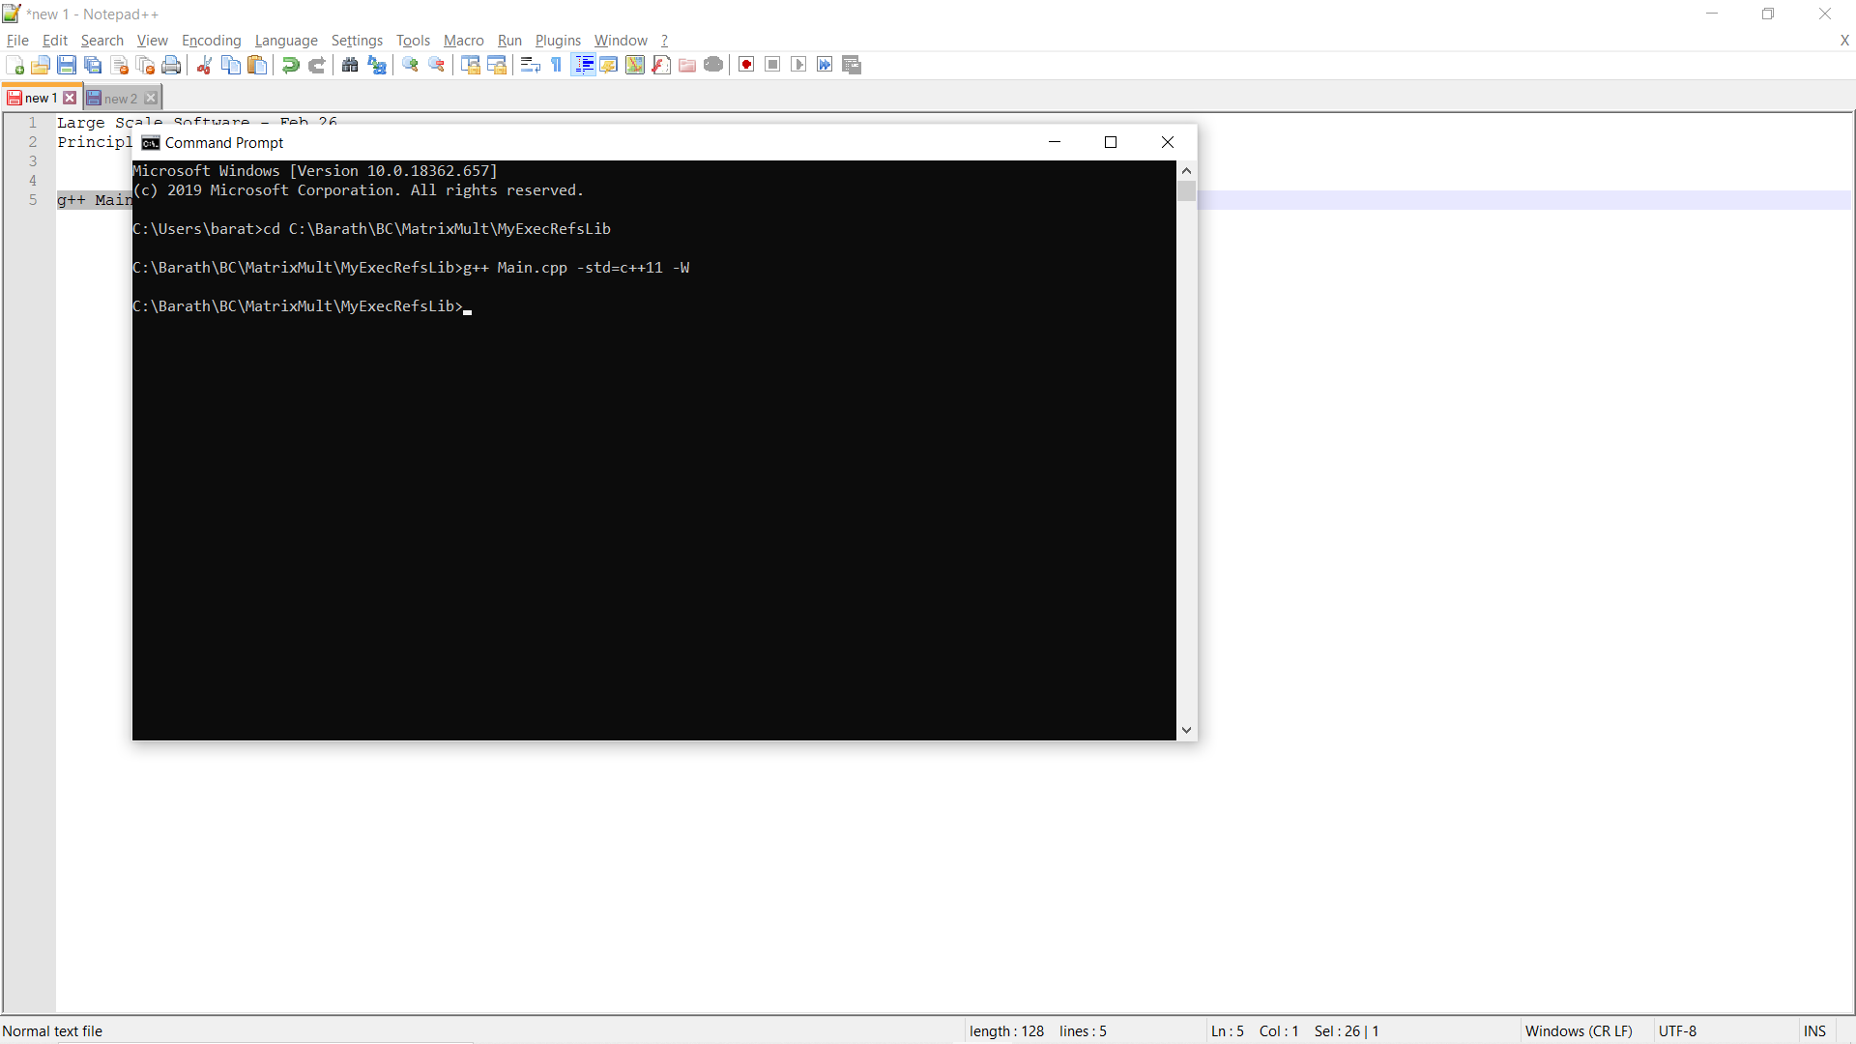

Compilation successful and ‘a.exe’ file will be created

* Run a.exe to run the program

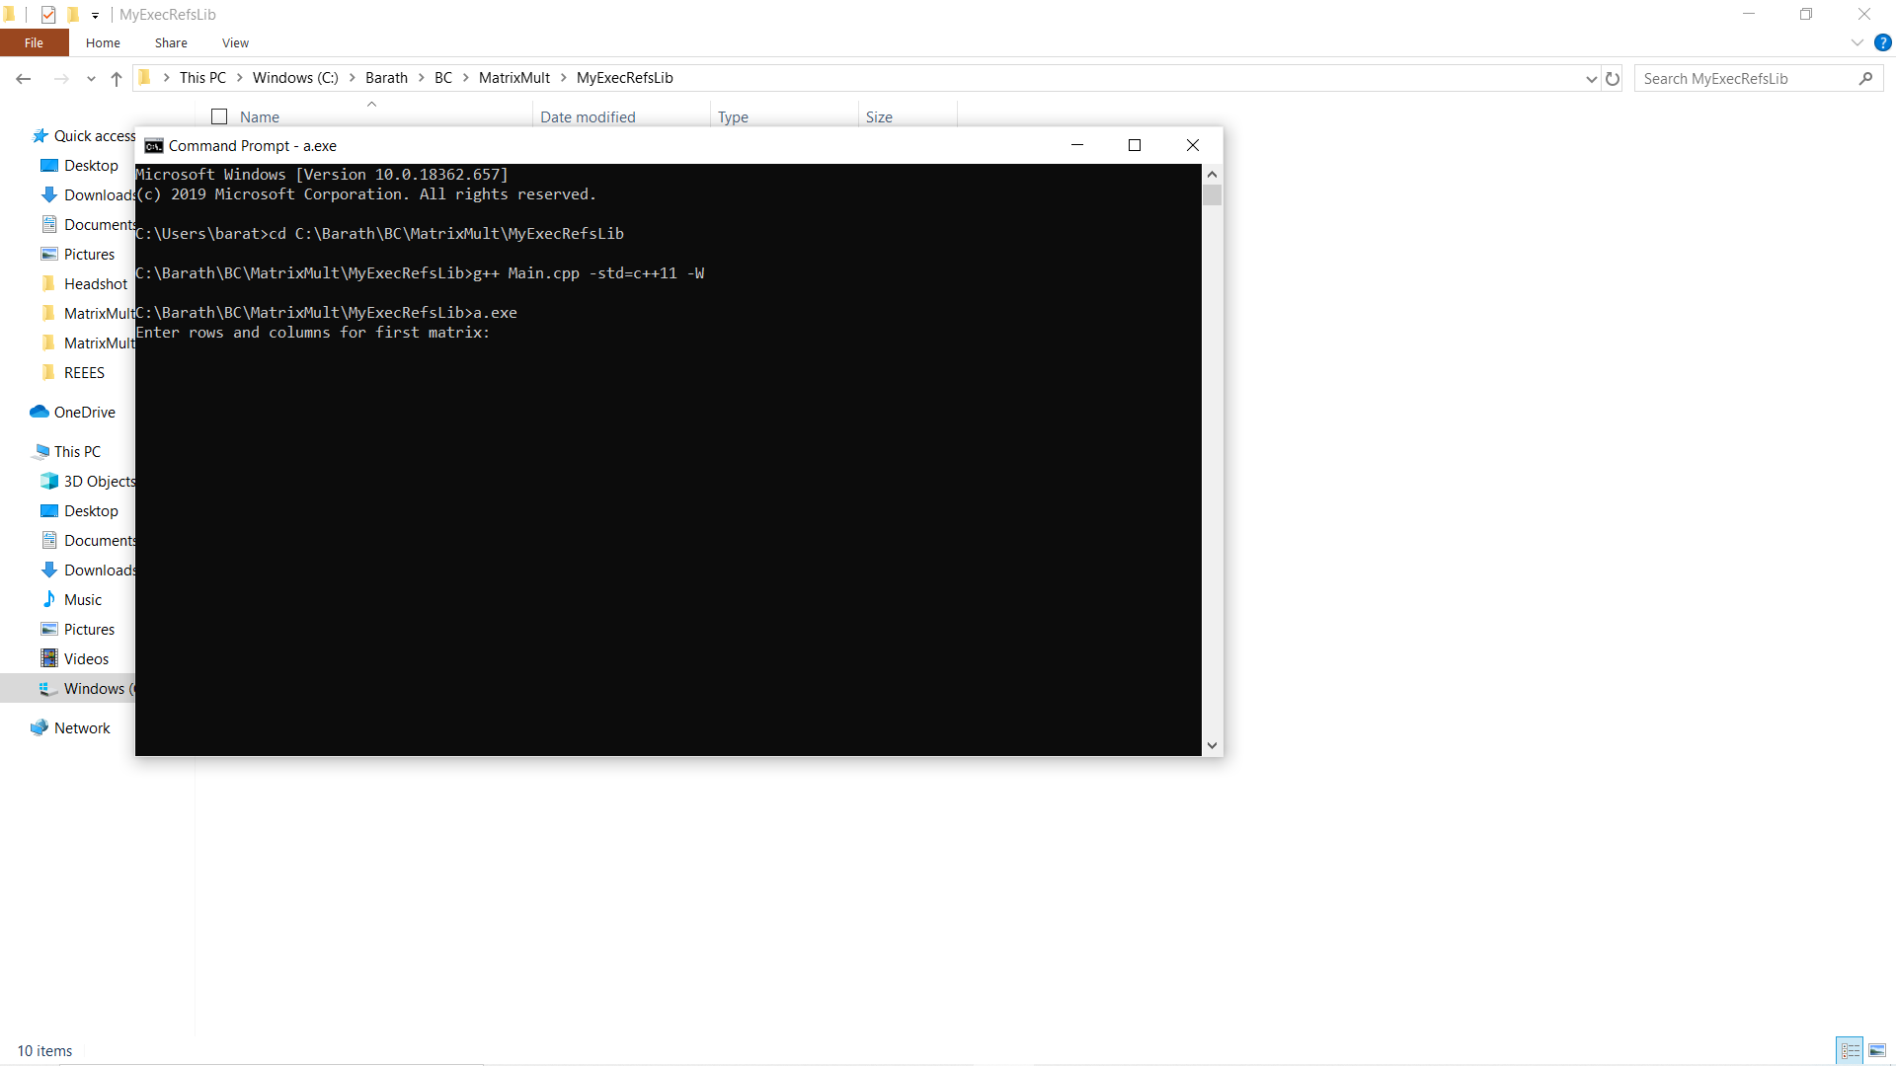

***SC01_TC01:***

Provide the number of rows and columns for matrix 1 and matrix 2 such that column of first matrix is same as rows of second matrix.

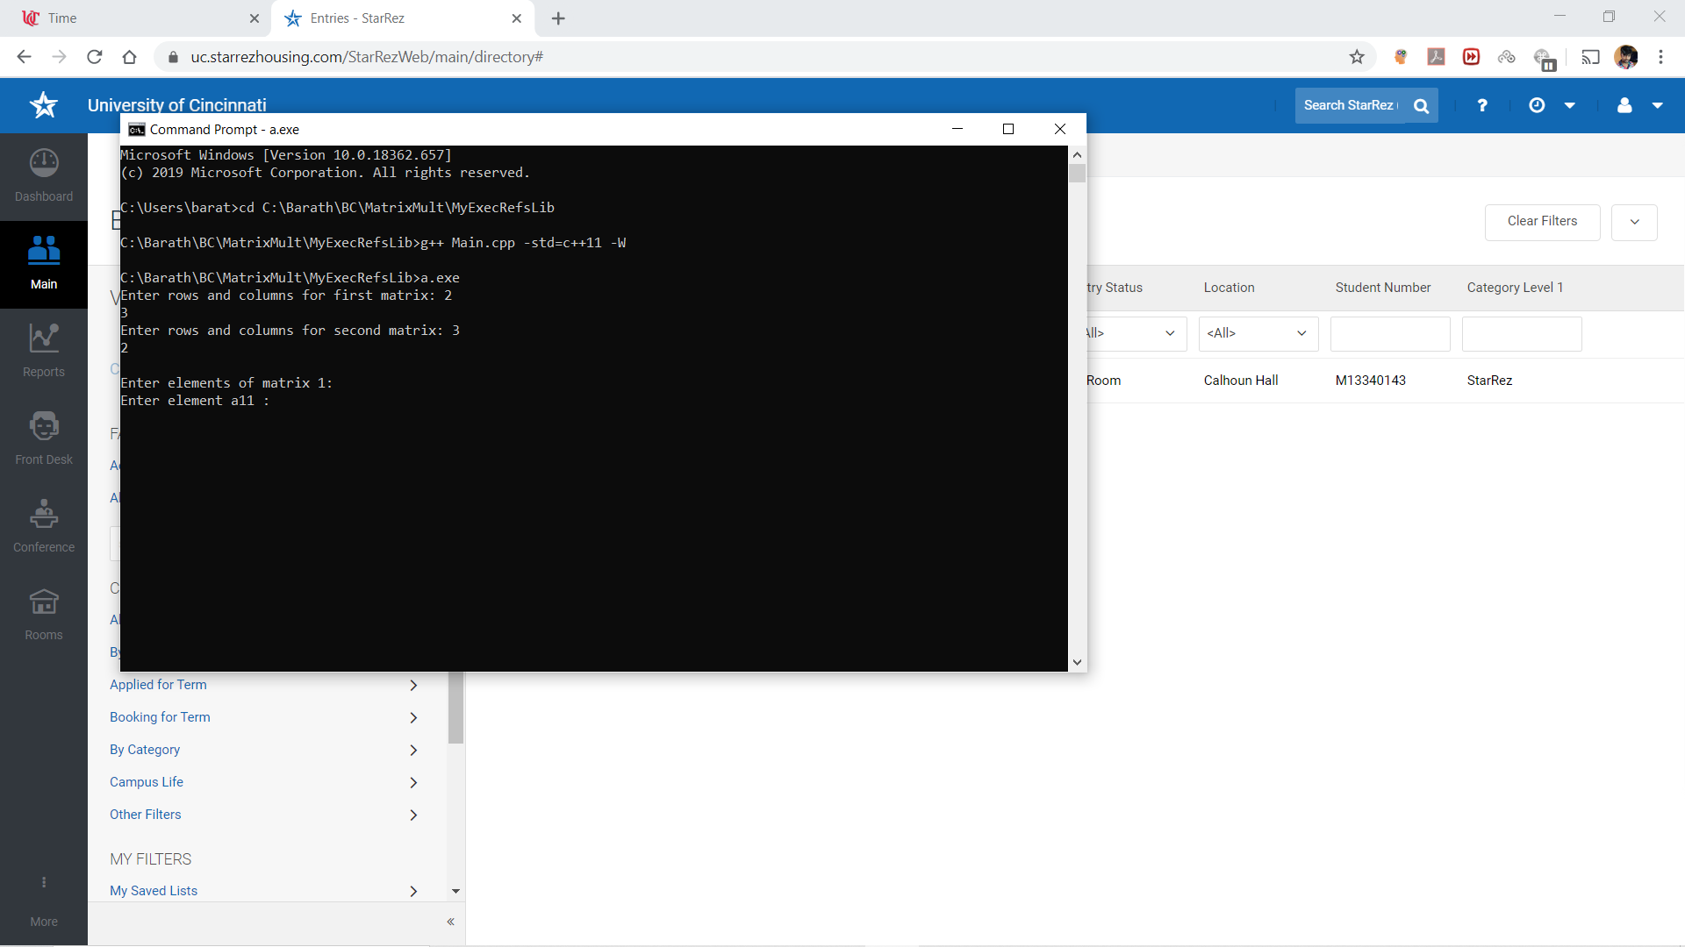

Provide the values for the matrix 1 and matrix 2

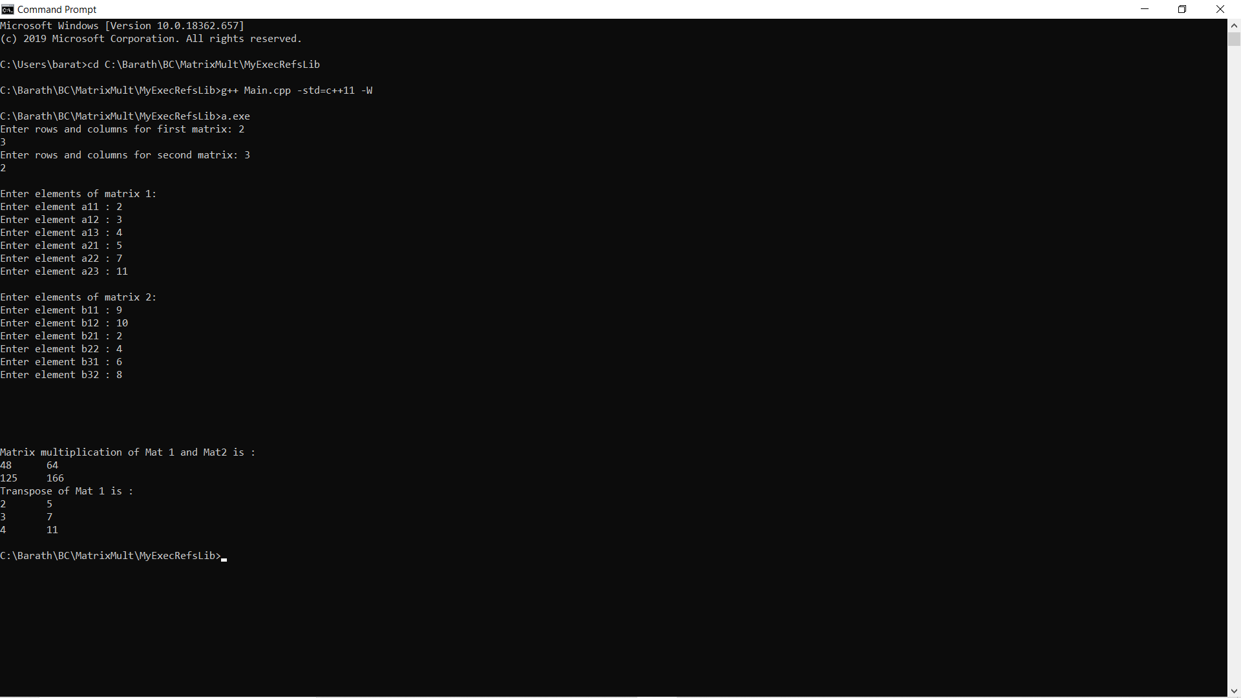

Resulting matrix should be as expected

We have obtained the matrix multiplication for Matrix 1 and Matrix 2

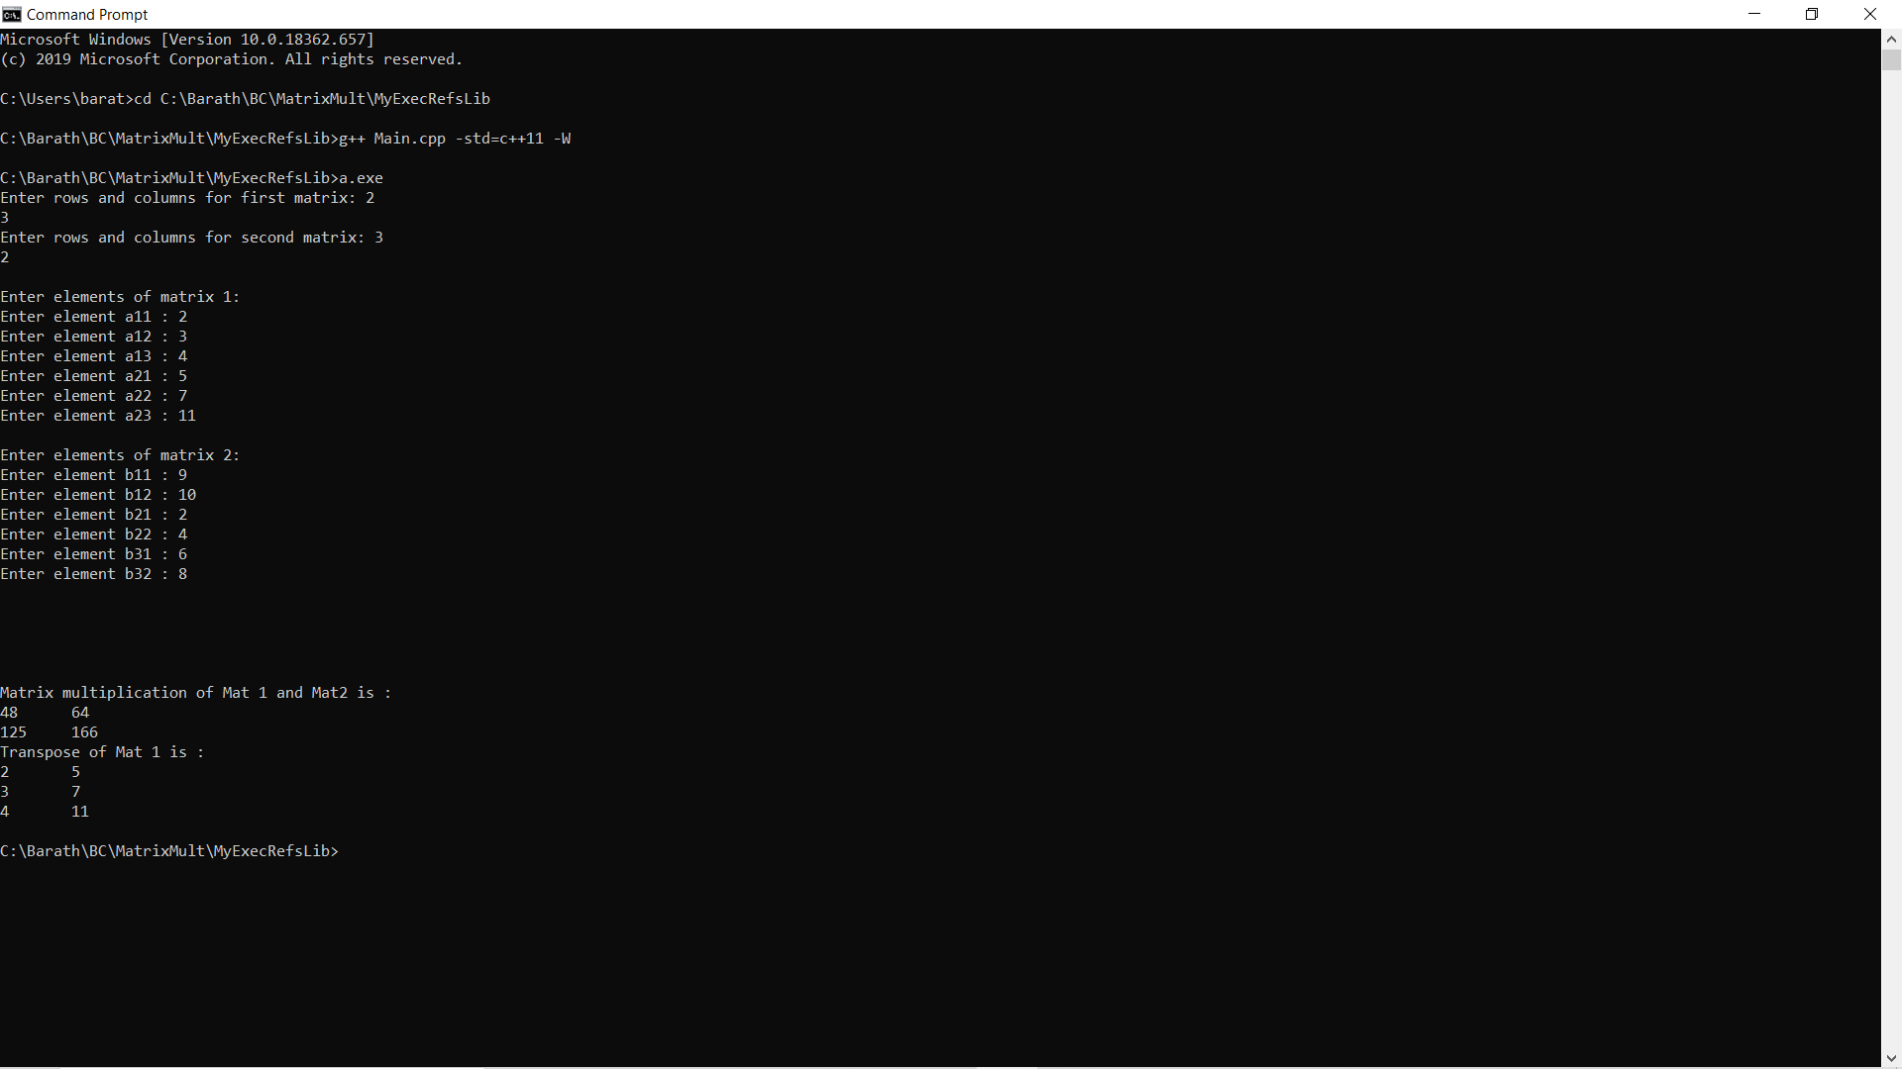

***SC01_TC02***

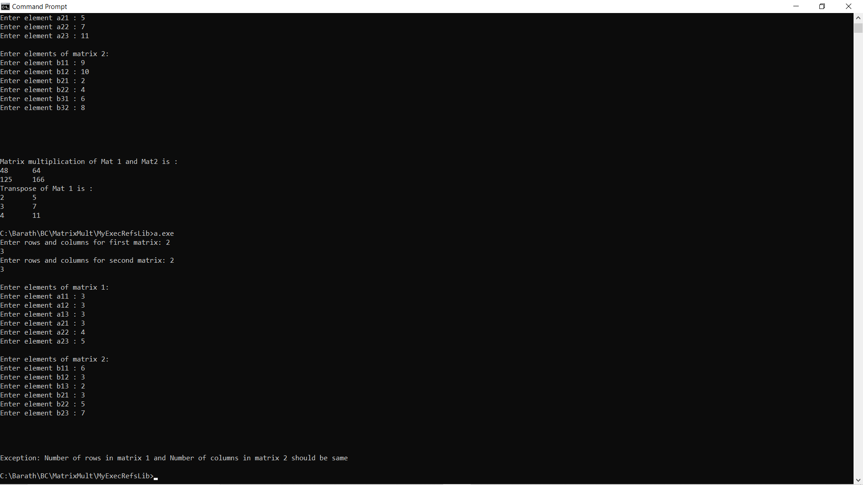

We can see the exception has been thrown when the number of columns in Matrix 1 and number o rows in Matrix 2 is different.

***SC01_TC03***

Provide the number of rows and columns for matrix 1 and matrix 2 such that negative values and zeroes are given.

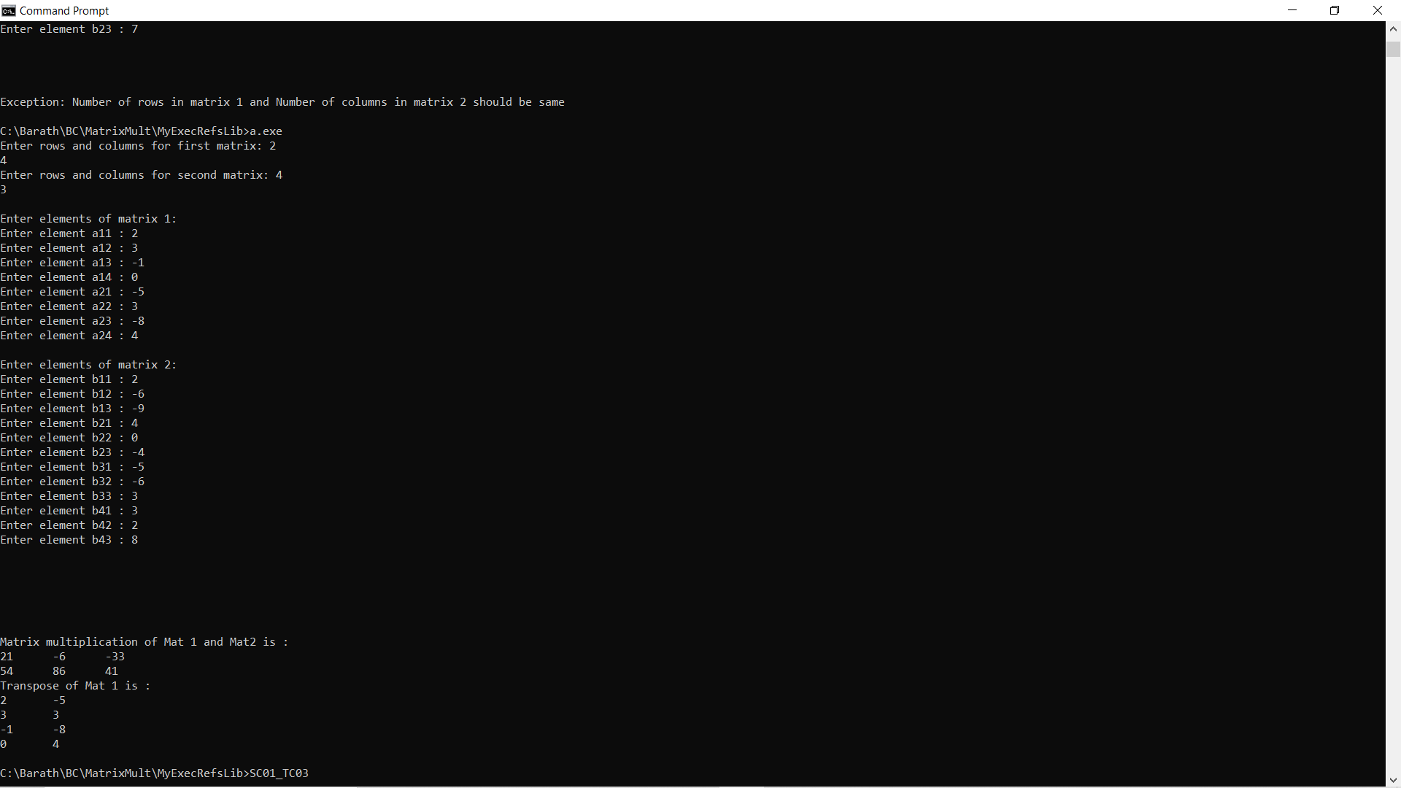

Resulting matrix should be as expected



***SC02_TC04***

Providethe number of rows and columns for matrix 1

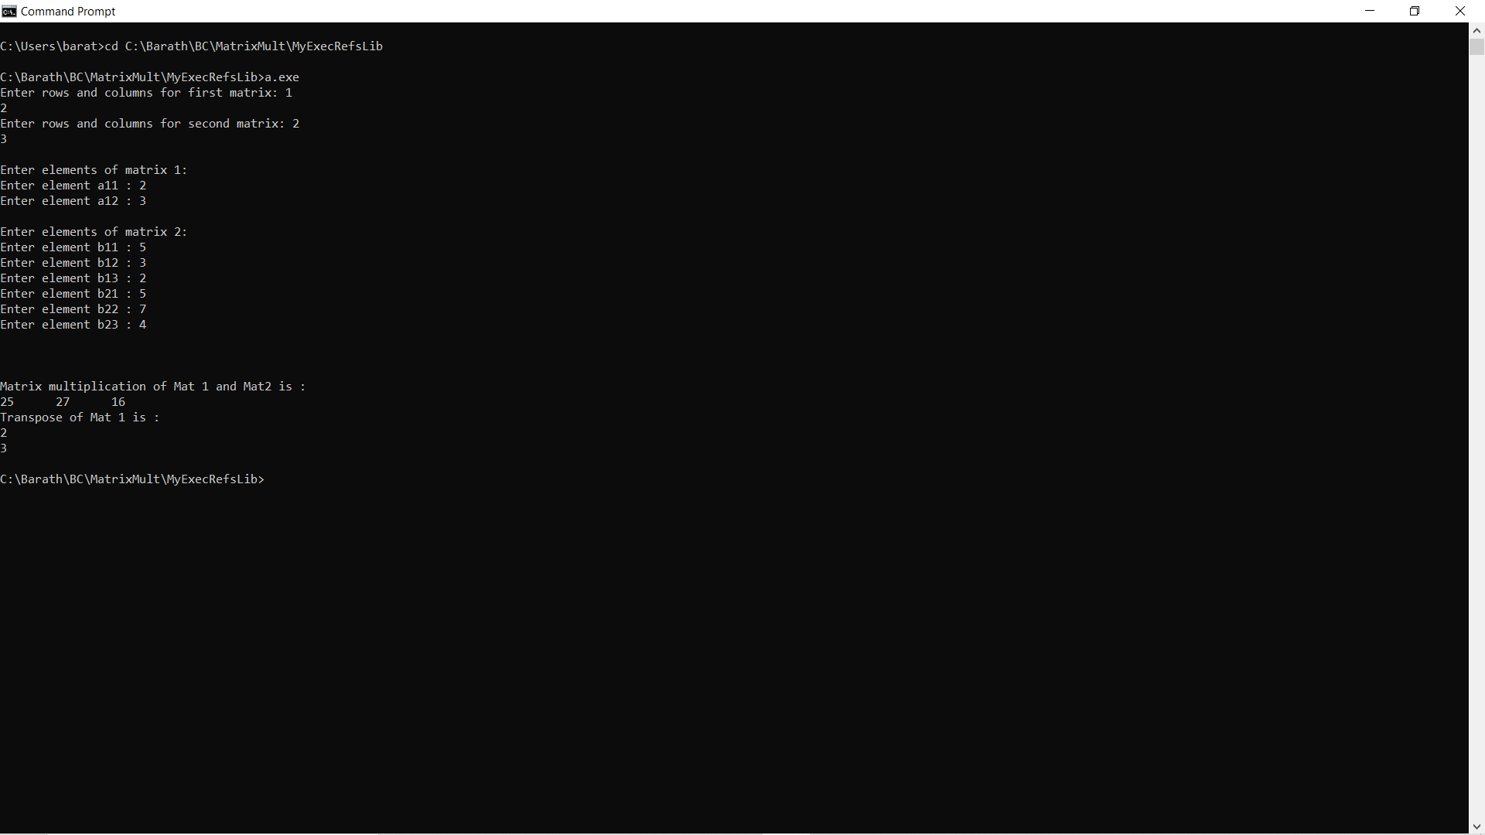

Provide the values for the matrix 1 and matrix 2

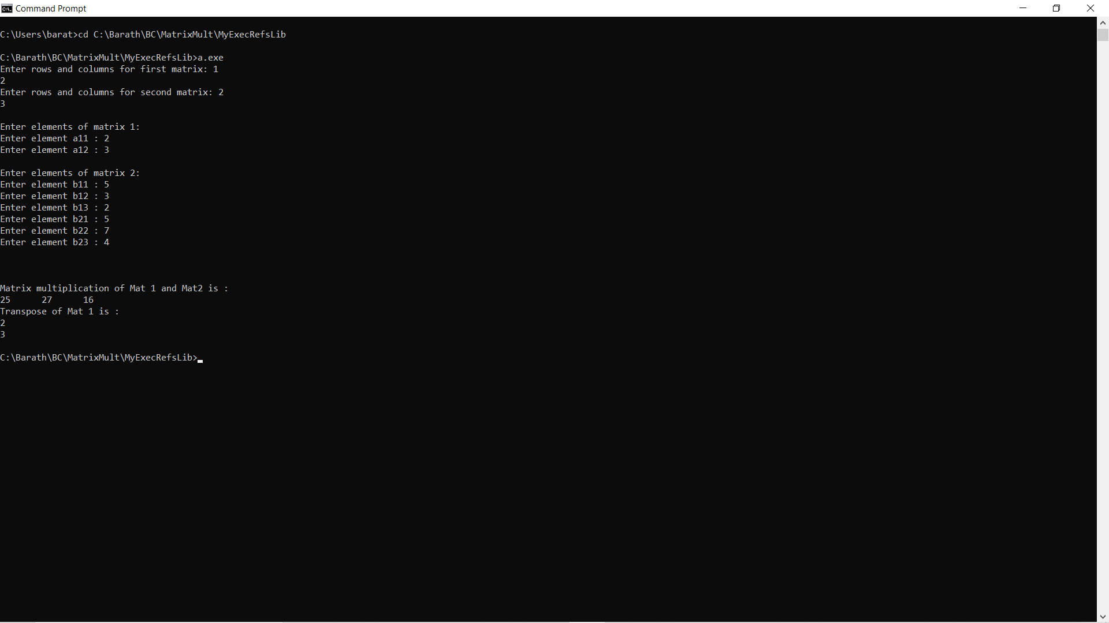

Resulting matrix should be as expected without any errors we can see the transpose of matrix 1

